**RAW ZUCCHINI NOODLE PAD THAI (IT'S VEGAN FRIENDLY!)**

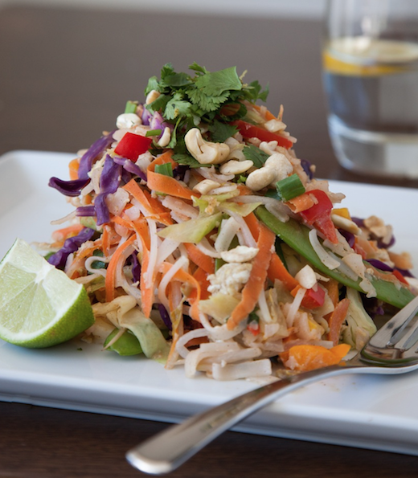

By Rachelle Girardin (Beyond Nourished)

**I once had a client tell me that I should quit my day job and just manufacture and sell this sauce, he also told me that he would choose this sauce as part of his ‘ last meal’. There is a perfect synergy of sweet, salty, and creamy that makes this sauce irresistible.**

Yields: 6-8 servings plus extra sauce

**Ingredients:**

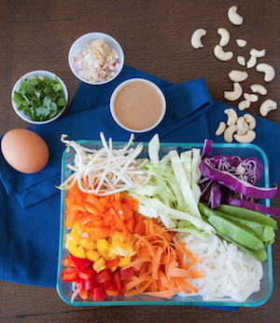Half a head of Purple Cabbage, thinly chopped  
1 medium Zucchini, thinly chopped  
4 Carrots, grated or use a mandolin  
2 Bell Peppers, thinly chopped  
4 cups Spinach or Romaine Lettuce  
3 small Bok Choy, chopped  
2 cups Bean Sprouts  
1 Bunch Cilantro Leaves, de-stemmed and chopped  
1 Pkg Kelp Noodles, soak, rinse and chop

**Creamy Almond Sauce**

**Ingredients:**

1 cup Raw Almond Butter  
2 Tbsp Fresh Ginger, grated  
1/2 cup Filtered Water  
4 Tbsp Fresh Lemon Juice  
1/4 Cup Pure Maple Syrup  
3 Tbsp Nama Shoyu, Tamari or Braggs  
4 teaspoon Sesame Oil  
2-3 Cloves Garlic  
1 tsp Chilli Flakes or 1/2 a Serrano Chile

**Directions:**

1. Drain kelp noodles from the liquid in the package and place noodles in a glass bowl and cover with water. Let stand for 15-20 minutes to allow to soften.  
   
2. Meanwhile, prepare (slice, chop, grate, ect...) vegetables into extra large bowl then add kelp noodles.   
  
3. Mix sauce ingredients in bowl or blender, until smooth and pour generously over ingredients until well coated. Allow time (15 min and upward) for sauce to incorporate into the noodles!  
   
4. Keep any extra sauce in a glass jar with tight fitting lid for up to 5 days refrigerated. Pad Thai will keep for 2 days. It is best to keep the sauce and vegetables separate, add the sauce just prior to eating.